**Running Spring Boot Apps from the Command Line**

**Spring Boot app run from command line**:

We can run our Spring Boot app from outside the IDE. We can run our Spring Boot application from command line. When running Spring Boot app from command line, no need to have IDE open or running.

Since we using Spring Boot, the server is embedded in our JAR file. No need to have separate server install or running. Spring Boot apps are self-containing.

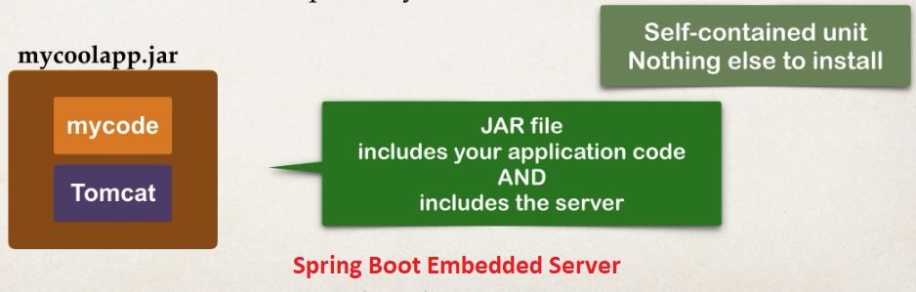

**Running App**:

There are two options for running the Spring Boot App.

1. Option-1: java -jar
2. Option-2: mvnw Spring-boot:run

**Option-1: use java -jar**:

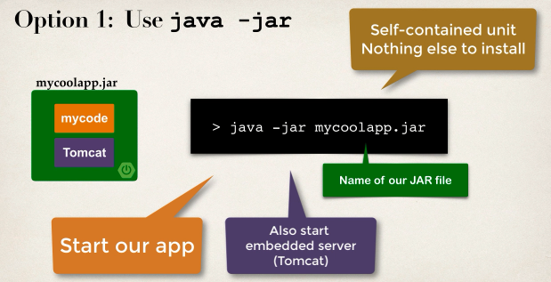

**Option-2) Use Spring Boot Maven plugin**:

1. The **mvnw** tool allows us to run Maven project.
2. No need to have Maven installed or present on our path.
3. If current version of Maven is not found I no our computer, automatically downloads current version and runs Maven.
4. Two files are providing
   1. **mvnw.cmd** for MS Window
   2. **mvnw.sh** for Linux / Mac
5. If already have Maven install previously, we can ignore / delete the **mvnw** files.
6. Just use Maven as our normal use.

In our "**pom.xml**" file we already have the Spring Boot Maven plugin.

<build>

<plugins>

<plugin>

<groupId>org.springframework.boot</groupId>

<artifactId>spring-boot-maven-plugin</artifactId>

</plugin>

</plugins>

</build>

**Development Process**:

1. Exit IDE
2. Package the app using **mvnw package**
3. Run app using **java -jar app_name**
4. Run app using Spring Boot Maven plugin **mvnw Spring-boot : run**

**Run App**:

1. First go to the project directory

**cd 72. Spring Boot - Running Spring Boot Apps from the Command Line**

1. Create package

**mvnw package**

1. Now Spring will create its required tools inside "**target**" folder

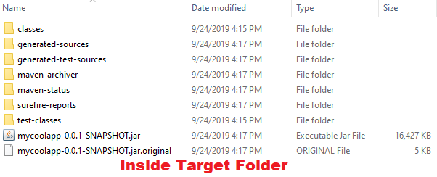

1. Go to target folder.

**cd target**

Inside the folder app jar file ("**mycoolapp-0.0.1-SNAPSHOT.jar**") is created.

1. Run the JAR file.

**java -jar mycoolapp-0.0.1-SNAPSHOT.jar**

Now our application is running. We can access it from our browser.

**Run App from using Spring Boot Maven plugin**:

1. Go to our root directory
2. Run **mvnw spring-boot:run**

72. Spring Boot - Running Spring Boot Apps from the Command Line